Linear Programming Approach |  | September 3  2025


DO THE MATH

Contents
Roster Planning in Airlines 2
Roster Plan 2
Traditional Way of Planning Roster 2
Optimization Techniques for Crew Rostering 2
Objective Function 3
Optimization Techniques 3
Suitable Optimization Model 4
Comparison with Other Optimization Techniques 5
Example Implementation 8

Roster Planning in Airlines

Roster Plan
A roster plan in the airline industry refers to the structured scheduling of crew members (pilots, cabin crew, instructors) across flights over a defined period (e.g., weekly, monthly). It ensures:
- Compliance with legal and operational constraints (e.g., duty hours, rest periods)
- Optimal crew utilization
- Coverage of all scheduled flights
- Accommodation of training, leave, and pairing requirements

Traditional Way of Planning Roster
Airlines typically follow a multi-phase planning cycle:
- Annual Planning: Fixed patterns, leave blocks
- Monthly Planning: Training sessions, draft/final rosters
- Daily Planning (D-1): Last-minute changes due to leave, medical issues
- Manual Tools Used: Excel sheets, macros, email-based communication, manual legality checks

Optimization Techniques for Crew Rostering
- Handle Complex Constraints
  - Automatically enforce hard rules like:
    - Flight Time Limitations (FTL)
    - Duty hours and sector limits
    - Training and pairing rules
    - Weekly rest requirements
- Objective-Driven Scheduling
  - Defining goals such as:
    - Minimize total duty hours
    - Balance workload across crew members
    - Reduce crew swaps and reassignments
- Speed and Scalability
  - Optimization solvers can generate rosters quickly, even for large datasets.
  - Ideal for TMA’s 2-hour daily planning window.
- Consistency and Automation
  - Produces repeatable, auditable results.
  - Reduces manual errors and improves compliance.

Objective Function
The goal is to optimize crew assignments while satisfying all operational and regulatory constraints. Possible objective functions include:
- Minimize total crew duty hours
- Maximize fairness in duty distribution
- Minimize crew swaps and reassignments
- Maximize crew utilization

Optimization Techniques
- Mixed Integer Programming (MIP)
  - Best for structured problems with binary decisions (assign/not assign).
  - Suitable for enforcing hard constraints.
- Constraint Programming (CP)
  - Ideal for complex rules like pairing, legality, and rest periods.
  - More flexible than MIP for rule-based logic.
- Heuristics / Metaheuristics
  - Techniques like Genetic Algorithms or Simulated Annealing.
  - Useful for large-scale problems with multiple objectives or soft constraints.
- Greedy Algorithms
  - Fast, rule-based assignment.
  - Good for simpler or real-time scenarios.
- Multi-objective Optimization
  - Balances multiple goals (e.g., fairness vs. efficiency).
  - Useful when soft constraints are also considered.

Suitable Optimization Model
The most appropriate model for this problem is Constraint Programming (CP) using Google OR-Tools. This model is designed for rule-based scheduling problems and supports:
- Multi-day planning logic (D, D+1, D+2)
- Complex constraint enforcement (FTL, pairing, legality)
- Fast and scalable execution for daily operations

Benefits of Using Google OR-Tools
- Automated Crew Assignment: Reduces manual effort and errors.
- Constraint Enforcement: Ensures compliance with FTL, duty hours, pairing rules, and 7legality.
- Workload Balancing: Distributes flying hours fairly across crew members.
- Operational Efficiency: Generates rosters within the required 2-hour window.
- Integration Capability: Can work with flight schedules, crew data, and training plans.
- Exportable Outputs: Generates Excel sheets or dashboard-ready formats

Objective Function
The optimization model aims to:
- Minimize total crew duty hours
- Maximize fairness in duty distribution
- Minimize crew swaps and reassignments
- Maximize crew utilization

Comparison with Other Optimization Techniques
Method | Suitability for Crew Rostering | Constraint Handling | Scalability | Speed | Ease of Use | Best Use Case
Google OR-Tools (CP) | Excellent | Strong | High | Fast | Moderate | Complex scheduling
Mixed Integer Programming | Good | Strong (linear) | Medium | Moderate | Moderate | Structured assignment problems
Heuristics / Metaheuristics | Good | Flexible | High | Variable | Moderate | Multi-objective problems
Greedy Algorithms | Basic | Weak | High | Fast | Easy | Real-time, simple rules

Google OR-Tools using Constraint Programming is the most feasible and effective solution for automating crew rostering at TMA. It offers:
- Strong constraint enforcement
- Fast and scalable performance
- Integration with operational data
- Reliable and repeatable results
Mathematical Representation of Constraints
Let:
- X_{i,j,d}​∈{0,1}: Binary decision variable indicating whether crew member ( i ) is assigned to flight ( j ) on day ( d ).
- H_{i,d} : Total duty hours for crew ( i ) on day ( d ).
- B_{i,d} : Block hours for crew ( i ) on day ( d ).
- S_{i,d} : Number of sectors assigned to crew ( i ) on day ( d ).
- T_{i,d} : Training status of crew ( i ) on day ( d ) (1 if in training, 0 otherwise).
- L_{i,d} : Legality status (1 if legal to fly, 0 otherwise).
- O_{i,d}: Overnight assignment status (1 if assigned overnight, 0 otherwise)

1. Flight Time Limitations (FTL)
- Daily FDP Limit:
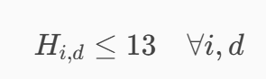
- 28-Day Block Hour Limit:
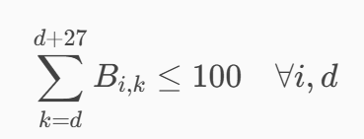
- Annual Block Hour Limit:
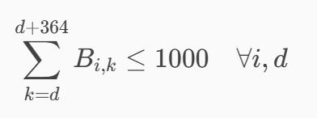
2. Sector Limits
- Daily Sector Limit:
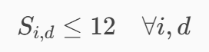
- Max 14 Sectors in One FDP (Twice a Week):
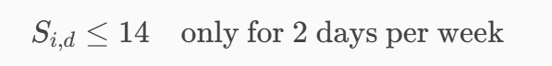
- Max 48 Sectors Between Extended Rest Periods:
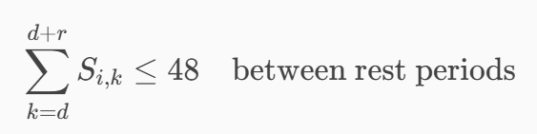
3. Weekly Duty Pattern
- Duty-Off Cycle:
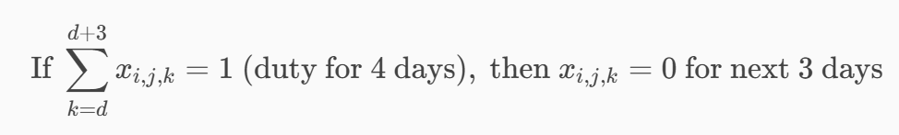
4. Crew Pairing Rules
- Valid Pairing:
5. Crew Legality
- License, Medical, Training Validity:
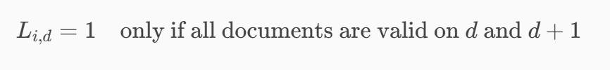
6. Aircraft Type Currency
- Crew Qualification for Aircraft Type:
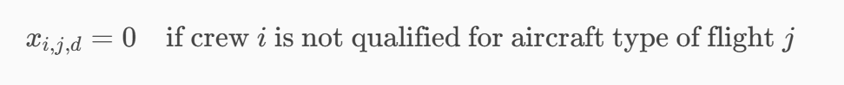
7. Training Requirements
- Training Pairing Enforcement:
8. Standby Duty Distribution
- Rolling 30-Day Standby Limit:
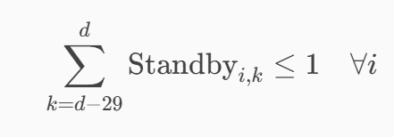
9. Overnight Assignment Rules
- Max 2 Consecutive Overnights:
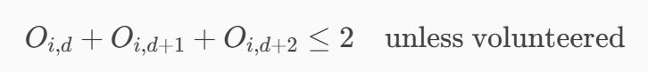
- Legality for D+2:
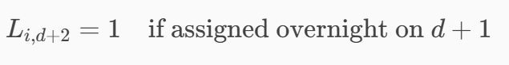

Example Implementation
Problem Statement:
Design a crew roster plan assigning crew members by role (Captain, First Officer, Attendant) to flights scheduled over the next three consecutive days, ensuring:
- Flight Coverage:
Each flight on each day must have exactly one Captain, one First Officer, and one Attendant assigned.
- Qualifications and Training:
Crew members can only be assigned to flights for which they are qualified for their specific role and have completed required training before the flight day.
- Daily Limits:
Each crew member’s daily flying hours and sector limits must not be exceeded.
- Crew Pairing Compatibility:
Incompatible crew members cannot be assigned together on the same flight.
- Training Validation:
Crew must have completed necessary training before flight day.
- Objective:
Find a feasible assignment of crew (with roles) to all flights in the 3-day period.
Implementation:
Variables:
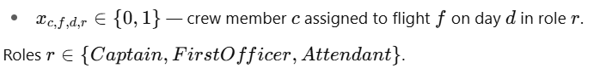

Constraints:
- Role coverage per flight:
For each flight f on day d,
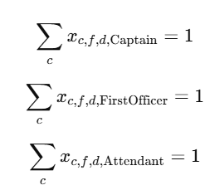
- Qualification:
Crew c can only be assigned to role r on flight f if qualified.
- Training:
Crew c must have completed training for flight f’s requirements before day d.
- Daily limits:
Sum of flying hours and sectors assigned to crew c on day d must be within limits.
- Pairing compatibility:
No incompatible crew assigned together on the same flight.

OR-Tools CP-SAT Model:
from ortools.sat.python import cp_model
# Sample Data (3 days, 3 flights)
days = [0, 1, 2]
flights = ['F1', 'F2', 'F3']
roles = ['Captain', 'FirstOfficer', 'Attendant']
flight_info = {
'F1': {'duration': 2, 'sectors': 1, 'training': 'T1'},
'F2': {'duration': 3, 'sectors': 1, 'training': 'T2'},
'F3': {'duration': 1.5, 'sectors': 1, 'training': 'T1'},
}
# Crew members with roles
crew = {
'C1': 'Captain',
'C2': 'FirstOfficer',
'C3': 'Attendant',
'C4': 'Captain',
'C5': 'FirstOfficer',
'C6': 'Attendant',
'C7': 'Captain',
'C8': 'FirstOfficer',
'C9': 'Attendant',
}
# Qualifications: which crew can fly which flights?
qualifications = {
'C1': ['F1', 'F2'],
'C2': ['F1', 'F3'],
'C3': ['F1', 'F3'],
'C4': ['F2', 'F3'],
'C5': ['F2', 'F3'],
'C6': ['F1', 'F2'],
'C7': ['F1', 'F3'],
'C8': ['F2', 'F3'],
'C9': ['F1', 'F2', 'F3'],
}
# Training completed by crew before day d
training_completion = {
'C1': {'T1': 0, 'T2': 0},
'C2': {'T1': 0, 'T2': 1},
'C3': {'T1': 1},
'C4': {'T1': 0, 'T2': 0},
'C5': {'T1': 0, 'T2': 0},
'C6': {'T1': 0, 'T2': 0},
'C7': {'T1': 0, 'T2': 0},
'C8': {'T1': 0, 'T2': 0},
'C9': {'T1': 0, 'T2': 1},
}
# Daily limits for crew: max hours and sectors
crew_limits = {
'C1': {'max_hours': 5, 'max_sectors': 2},
'C2': {'max_hours': 5, 'max_sectors': 2},
'C3': {'max_hours': 4, 'max_sectors': 2},
'C4': {'max_hours': 5, 'max_sectors': 2},
'C5': {'max_hours': 5, 'max_sectors': 2},
'C6': {'max_hours': 4, 'max_sectors': 2},
'C7': {'max_hours': 5, 'max_sectors': 2},
'C8': {'max_hours': 5, 'max_sectors': 2},
'C9': {'max_hours': 4, 'max_sectors': 2},
}
# Incompatible crew pairs (cannot be assigned on same flight same day)
incompatible_pairs = [('C1', 'C3'), ('C4', 'C6')]
# Model
model = cp_model.CpModel()
# Variables: x[c,f,d,r] = 1 if crew c assigned to flight f on day d in role r
x = {}
for c in crew:
for f in flights:
for d in days:
for r in roles:
x[(c,f,d,r)] = model.NewBoolVar(f'x_{c}_{f}_{d}_{r}')
# Constraint 1: Each flight per day must have exactly one crew per role
for f in flights:
for d in days:
for r in roles:
model.AddExactlyOne(x[(c,f,d,r)] for c in crew if crew[c] == r)
# Constraint 2: Assign only qualified crew to flights and matching role
for c in crew:
c_role = crew[c]
for f in flights:
for d in days:
if f not in qualifications[c]:
model.Add(x[(c,f,d,c_role)] == 0)
for r in roles:
if r != c_role:
model.Add(x[(c,f,d,r)] == 0)
# Constraint 3: Crew must have completed training before flight day
for c in crew:
c_role = crew[c]
for f in flights:
training_needed = flight_info[f]['training']
for d in days:
if training_needed not in training_completion[c]:
model.Add(x[(c,f,d,c_role)] == 0)
else:
# Training must be completed **before** day d (strict)
if training_completion[c][training_needed] >= d:
model.Add(x[(c,f,d,c_role)] == 0)
# Constraint 4: Daily flying hours and sector limits per crew
for c in crew:
c_role = crew[c]
max_hours = crew_limits[c]['max_hours']
max_sectors = crew_limits[c]['max_sectors']
for d in days:
flight_hours = []
flight_sectors = []
for f in flights:
# Multiply duration by 10 to avoid float (int constraint)
flight_hours.append(x[(c,f,d,c_role)] * int(flight_info[f]['duration'] * 10))
flight_sectors.append(x[(c,f,d,c_role)] * flight_info[f]['sectors'])
model.Add(sum(flight_hours) <= max_hours * 10)
model.Add(sum(flight_sectors) <= max_sectors)
# Constraint 5: Incompatible crew cannot be assigned to same flight on same day
for (c1, c2) in incompatible_pairs:
for f in flights:
for d in days:
# For all role pairs, incompatible crew cannot both be assigned on the same flight/day
clauses = []
for r1 in roles:
for r2 in roles:
clauses.append(x[(c1,f,d,r1)].Not())
clauses.append(x[(c2,f,d,r2)].Not())
# At least one of these must be true (meaning incompatible crew not assigned together)
# This is equivalent to: NOT (c1 assigned AND c2 assigned)
# So add pairwise disjunctions to forbid simultaneous assignments
# Simplify by adding pairwise constraints:
for r1 in roles:
for r2 in roles:
model.AddBoolOr([x[(c1,f,d,r1)].Not(), x[(c2,f,d,r2)].Not()])
# Objective: Find feasible solution only
model.Minimize(0)
# Solve
solver = cp_model.CpSolver()
status = solver.Solve(model)
# Output
if status == cp_model.FEASIBLE or status == cp_model.OPTIMAL:
for d in days:
print(f"\nDay {d+1} assignments:")
for f in flights:
assigned = []
for r in roles:
for c in crew:
if solver.BooleanValue(x[(c,f,d,r)]):
assigned.append(f"{r}: {c}")
print(f" Flight {f}: {', '.join(assigned)}")
else:
print("No feasible solution found.")

Generated Output:
Day 1 assignments:
Flight F1: Captain: C1, FirstOfficer: C2, Attendant: C9
Flight F2: Captain: C4, FirstOfficer: C5, Attendant: C6
Flight F3: Captain: C7, FirstOfficer: C8, Attendant: C3

Day 2 assignments:
Flight F1: Captain: C1, FirstOfficer: C2, Attendant: C9
Flight F2: Captain: C4, FirstOfficer: C5, Attendant: C6
Flight F3: Captain: C7, FirstOfficer: C8, Attendant: C3

Day 3 assignments:
Flight F1: Captain: C1, FirstOfficer: C2, Attendant: C9
Flight F2: Captain: C4, FirstOfficer: C5, Attendant: C6
Flight F3: Captain: C7, FirstOfficer: C8, Attendant: C3

